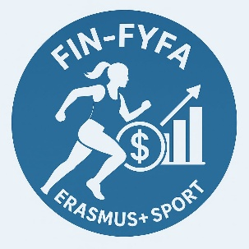

Report – First Training Session (FIN-FYFA Workshop)
The first part of the FIN-FYFA workshop, Financial Foundations for Young Female Athletes, was successfully held on 30 March and organized by ŽFK Borec. The session introduced participants to the importance of financial literacy in sports and everyday life.
During the training, participants were familiarized with the structure of the program and key concepts such as personal budgeting, financial planning, and understanding income and expenses. Through interactive discussions and practical exercises, the athletes started developing their own “Financial Game Plan” using the Financial Compass tool .
Special focus was placed on raising awareness about financial decision-making, managing daily expenses, and preparing for future financial stability. Participants actively engaged in exercises and reflections, connecting financial concepts with their personal and sporting realities.
This training represents the first of three planned sessions organized by ŽFK Borec, aiming to strengthen financial knowledge and support young female athletes in building smart and sustainable futures.

